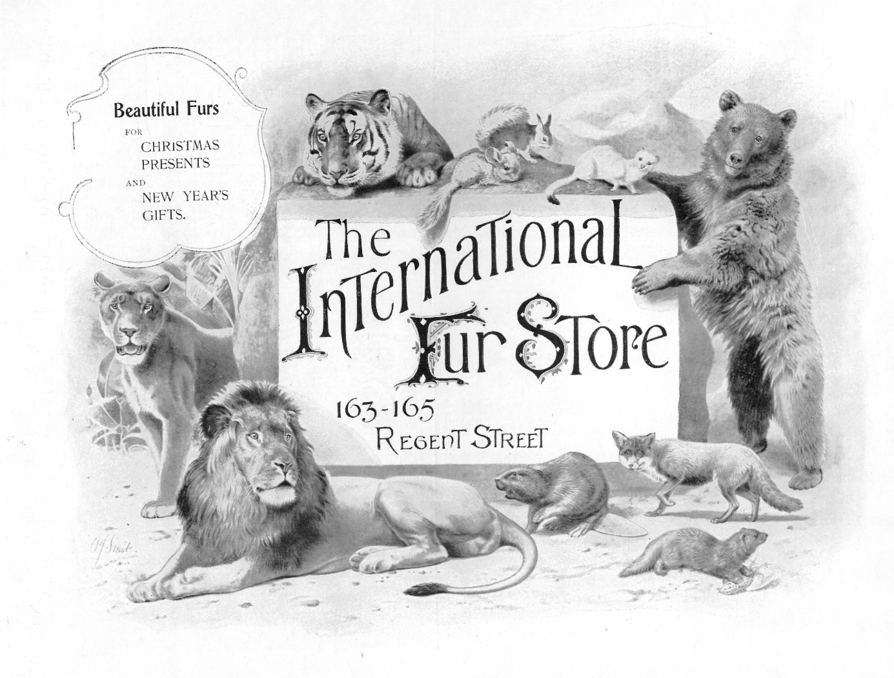

***Fur, Fin and Feather: Commodifying Wild Animals***

**Commodities of Empire International Workshop, University of York, 6-7 July 2023**

**Venue**

The Treehouse,

Berrick Saul Building,

University of York

PROVISIONAL PROGRAMME

**DAY 1**

**Thursday 6 July 2023**

9h00-9h30

**Welcome Remarks**

9h30-11h00

**Panel 1: Trading Animal Body Parts**

Chair: Jean Stubbs / Discussant: Samuel Coghe

* Clément Beauvarlet: Turtle shells for tobacco, pearls for calico: Integrating Micronesia into imperial commodity chains
* Robert Harms: Forest Elephant Ivory in Nineteenth Century Africa
* Laura Valls: Exhibiting exotic animal skins: geographies of fur and feather artefacts in nineteenth-century Paris

11h00-11h30: coffee/tea break

11h30-13h00

**Panel 2: Animal Dyes and Perfumes**

Chair: Helen Cowie / Discussant: Jean Stubbs

* Nir Eydan: Ambergris, the colonial commodity that never was
* Diana Heredia-Lopez: The red dyad of fine and wild cochineal: on the creation of commercial categories in early modern Hispanic commerce
* Sarah-Maria Schober: Beyond Exoticism: The Early Modern History of Europe’s Civet Cats and Our Colonial Heritage

13h00-14h00: lunch

14h00-15h30

**Panel 3: The Live Animal Trade**

Chair: Samuel Coghe / Discussant: Corey Ross

* Abdul Wahid: Under the shadow of Imperial connection: The exchange of information and wild-animals between Batavia’s Bataviasche Planten en Dierentuin and Amsterdam’s Artis Natura Magistra,1860s-1930s
* Lars Kury: Infrastructuring the Colonial Wildlife Trade: The Making of an Animal Transit Corridor in the Strait of Malacca at around 1900
* Tom Quick: Flying Monkeys and the Polio Vaccine: A Logistical History of the Rhesus macaque

15h30-16h00: coffee/tea break

16h00-17h30 (Chair: Jon Curry-Machado)

**New Book Panel** - A chance to share recent publications on global commodities. This panel will include presentations on:

* Jon Curry-Machado, William Clarence-Smith, Jean Stubbs and Jelmer Vos (eds.) *The Oxford Handbook of Commodities History* (forthcoming 2023)
* Ulbe Bosma, *The World of Sugar* (2023)
* Jean Stubbs, Tobacco on the Periphery: A Case Study in Cuban Labour History, 1860–1958 (new edition)

There will also be an opportunity for workshop participants with recent book publications to share them with the group. If you have a recent publication that you would like to share, or flyers that you would like to distribute, please bring them along with you for inclusion in a small display.

19h00-

**Conference Dinner, Ask Italian, The Grand Assembly Rooms, Blake Street, York, YO1 8QG**

**DAY 2**

**Friday 7 July 2023**

9h30-11h00

**Panel 4: Animals in Entertainment**

Chair: Ulbe Bosma / Discussant: Helen Cowie

* Prima Nurahmi Mulyasari: From military service to the exhibition in Zoological Gardens: Army Elephants in the Dutch East Indies
* Deniz Dölek-Sever: Visual Use of Captive Wild Animals in the Ottoman Empire: A History of Change and Continuity
* Hannah O’Regan, Liam Lewis, Sophy Charlton and Lizzie Wright: Box Office Bears

11h00-11h30: coffee/tea break

11h30-13h00

**Panel 5: Acclimatisation and Taming**

Chair: William Clarence-Smith / Discussant: Alexander van Wickeren

* Santhosh Abraham and Susy Varughese: Madras Kraals, Veterinary Corps and Ivory Trade: Colonising Wild Elephants in British South India
* Matthew Carter: Acclimatisation and the commercial gaze: how the muskox and the nilgai were commodified in late-eighteenth and early-nineteenth-century British popular natural history
* Vanessa Bateman: The Crown Herd: Acclimatization, Hybridization, and Commodification of Wapiti in New Zealand 1905 – Present

13h00-14h00: lunch

14h00-15h00

**Final Discussion**

**Supported By:**

 